**Theory Assignment 1 - Software Project management Gautam Bhatia – E19CSE223 – EB13**

**Software Requirements Specifications - Online Furniture Shopping System**

**1. Introduction**

1. **Purpose**

The purpose of this SRS document is to build an online shopping system for furniture items that will provide customers to browse and buy variety of furniture items of different companies at one place without going to the shops physically. Company owners or furniture traders can list their furniture items, which will expand the shop’s business network nationally and globally. System Administrator will manage the company products, customer transactions and interaction between the two parties.

1. **Scope**

The system will allow customers to add or remove furniture products from their online cart and purchase the final cart items via different payment methods. Furniture shop owners can create new product categories and list their furniture items including the images from all angles, description, etc.

1. **Intended audience:**

This SRS document is intended for requirement analyst, software designer, developers, testers and product managers and other stakeholders like marketing team, sales team and financial team.

1. **Document conventions**

DBMS: Database Management System

1. **References:**

[How to Write a Software Requirements Specification (SRS Document) | Perforce](https://www.perforce.com/blog/alm/how-write-software-requirements-specification-srs-document)

**2. Overall Description**

1. **Product Perspective**

Normally, people go physically to dedicated furniture markets to buy new furniture for their home or offices and compare the product’s price, size, quality in almost all furniture shops of the market or sometimes travel far away furniture shops. Online software system for furniture items will be help the customers who can’t come to furniture shops and waste their valuable time in traveling and bargaining the prices. The website would made easy for the customers to compare and buy the furniture items required just sitting at their home and do time waste formalities.

1. **Product features**

Customer:

* New customer has to first make new account and enter email id, password in the website. Login credentials will be saved in the relational DB.
* Then customer can search and browse the required furniture item, read the description, review and compare furniture items provided by different companies.
* Customer has the privilege to add items in cart and remove them.
* They can also call or message the company officials from the website if need further clarity about the furniture product.
* Customer can also give ratings and feedback about quality, price, size, etc. which can motivate vendors to improve the quality of product offered.
* Payment can be done using various methods like pay-on-delivery, net banking, vouchers/gift cards, debit/credit card, UPI, etc.
* If product delivered is broken, quality or size of the product does not meet the customer expectations, then they can put request on the website to return/replace furniture item after 7 days of delivery.

Furniture manufacturer/shop vendor:

* Register their company in the website. The website would authenticate the shop and shop owners license and identity using government unique ids. Shop data will be in secured relational DB in backend.
* They can list in the furniture items they can sell, manufacture and deliver through website.
* Add/remove the furniture items when required.
* Offer shop/company’s discount, vouchers, schemes in festival durations.
* Can remove themselves from the website.

System Administrator:

* Access of customer transactions and items bought.
* Controlling the access permissions of customers and shop vendors.
* Accepting/rejecting application of registration in website given by shop vendor/company.
* Removing unappropriated furniture items.
* Checks sales and popularity of furniture items.
* Getting sponsors and ads.
* Manage customer and shop vendor database.
* Manage best selling price of all furniture products according to current market demand-supply so that it is beneficial for both customer and shop vendor.

1. **Software requirements**

* MERN stack: Mongo DB, Express, React, Node.js
* Frontend: HTML, CSS, JavaScript, Java
* Backend: Django
* IDE: VS Code, Android studio
* Version control and discussion: Git, GitHub, Slack
* DSA, SSH and HTTP/HTTPS
* Cryptography: AES-256 cipher
* Operating environment: Windows and Linux
* Client-server architecture
* Cloud service: AWS
* CI/CD: Jenkins, Gradle, puppet

1. **Hardware requirements**

* Core i3, i5, and above processors
* Minimum 2GB RAM
* Minimum 500 Hard Disk
* Android and IOS

1. **Technical Constraints**

* Good internet connection
* SQL injection and DDOS attacks.
* Database must be encrypted.
* User knowledge of login, browsing through the website, logout, doing payment.
* Continuous integration and delivery.
* Coding website with efficient code that utilise less RAM and CPU processing time.
* Developing the website that suits the design and user expectation and requirement.

1. **Non-technical constraints**

* Ability of shop vendors to deliver the furniture product at any location possible to win the customer satisfaction.
* Ability of shop vendors to generate enough product to meet demand-supply requirements in peak season.
* Attracting shop vendors to sell and customers to purchase furniture items using different means- newspaper, google and YouTube ads, TV ads, etc.
* Maintaining smooth transaction mechanism without any bugs and obstacles.
* Dividing revenue generated after selling, between website owner and furniture vendor.

**3. Functional requirements**

* New account: customer/shop vendor need to register on the website otherwise he/she will be not able to buy the product.
* Login: existing user need to enter valid login credentials to put and buy the products in cart.
* Search: customer can search the name and company of the furniture item like table, chair, bed, almirah, etc., and by clicking enter/search button, a list of specific company items or list of furniture items written on the search bar appears.
* Cart: ability of the customer to add products that are in stock in the cart.
* Payment: cash-on-delivery, net banking, etc.
* Ability of shop vendor to upload/remove information about new product.
* Ability of shop vendor to view previous sales details and upcoming orders placed for them.
* Ability of the shop vendor to add any kind information about the furniture product.
* Ability of the customer to monitor the movement of furniture item, starting from paying the bill, selecting the shop branch, driver picking the item, to delivery of the product.
* Website should display the approximate delivery date and doing payment.
* Ability of the website to display live location of the furniture after it is dispatched from the shop go-down.
* Ability of the system administrator to view all interaction happening between the shop vendor and customer, customer purchases, vendor sales, accept/reject new vendor application, suspend/ban any vendor if mistakes done by the vendors in product quality increases above the threshold.
* **Activity Diagram**

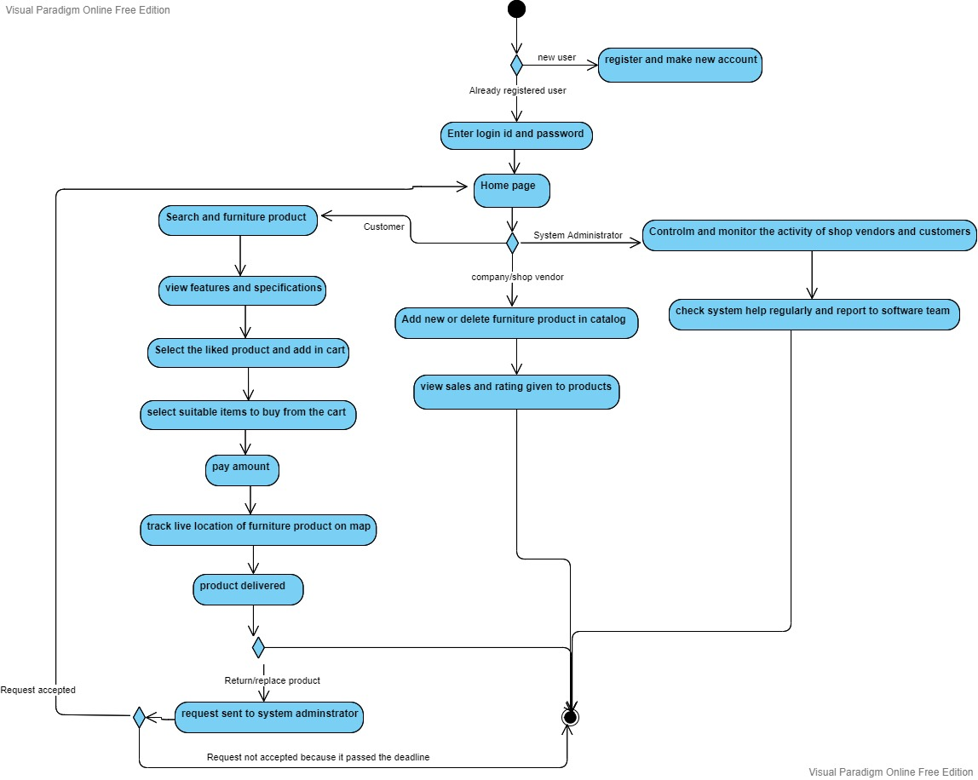

**4. Non-functional requirements**

1. **Security**: customer and shop vendor database in AWS cloud is encrypted from hackers using Advanced encryption standard technique.
2. **Availability**: 24x7 availability of all website features is provided through strong and verified network of AWS cloud datacentres.
3. **Reliability**: system will continue operating normally despite any fault or disaster occurs. Delivery of the product to customer location made possible whatever the unseen problems come in the way.
4. **Maintainability**: product price is maintained by the system administrator and shop vendors time-to-time. Website code is maintained, updated and released without having the customer to configure something extra apart from login credentials. Maintaining database efficiently so that querying results can be outputted accurately.
5. Smooth process of returning/replacing the furniture with less customer involvement.